# OODP Workshop 8

1. What is the difference between Array and ArrayList?
2. Create an arrayList named List which will store string values and demonstrate add names, delete names, insert names of your friends into it and print them using loop.
3. Think about yourself as an object, identify attributes and behavior that you can possess in one payroll system.
4. Think about a product that you have in front of you, find out attributes and behavior that can possessed by this product.

1. Ans:

In Java, Arrays and ArrayLists are both used to store collections of elements, but they have some fundamental differences. Here's a table that highlights the key differences between them with small examples:

|  |  |  |
| --- | --- | --- |
| **Aspect** | **Array** | **ArrayList** |
| Definition | Arrays are static data structures with a fixed size. | ArrayLists are dynamic data structures that can grow or shrink in size. |
| Example | int[] arr = new int[5]; | ArrayList<Integer> list = new ArrayList<>(); |
| Size | The size of an array is fixed and determined during its creation. | The size of an ArrayList can change dynamically at runtime. |
| Example | int[] numbers = {1, 2, 3, 4, 5}; | list.add(1); list.add(2); list.add(3); |
| Memory | Arrays are more memory-efficient as they store elements contiguously in memory. | ArrayLists have some overhead due to dynamic resizing and extra object creation. |
| Adding/Removing Elements | Arrays do not provide built-in methods to add or remove elements. You need to create a new array or use System utility methods. | ArrayLists provide built-in methods like add(), remove(), addAll(), and removeAll() to manipulate elements. |
| Example | (Adding an element is not straightforward) | list.add(4); list.remove(2); |
| Access Time | Arrays provide constant-time access to elements using indexes. | ArrayLists also provide constant-time access to elements using indexes, but with some overhead due to additional operations. |
| Example | int value = numbers[2]; // Constant-time access | int value = list.get(2); // Constant-time access |
| Primitives vs. Objects | Arrays can store both primitive data types (e.g., int, double) and objects. | ArrayLists can only store objects (including wrapped primitive types like Integer, Double). |
| Example | int[] arr = {1, 2, 3}; | ArrayList<Integer> list = new ArrayList<>(Arrays.asList(1, 2, 3)); |

2. Ans:

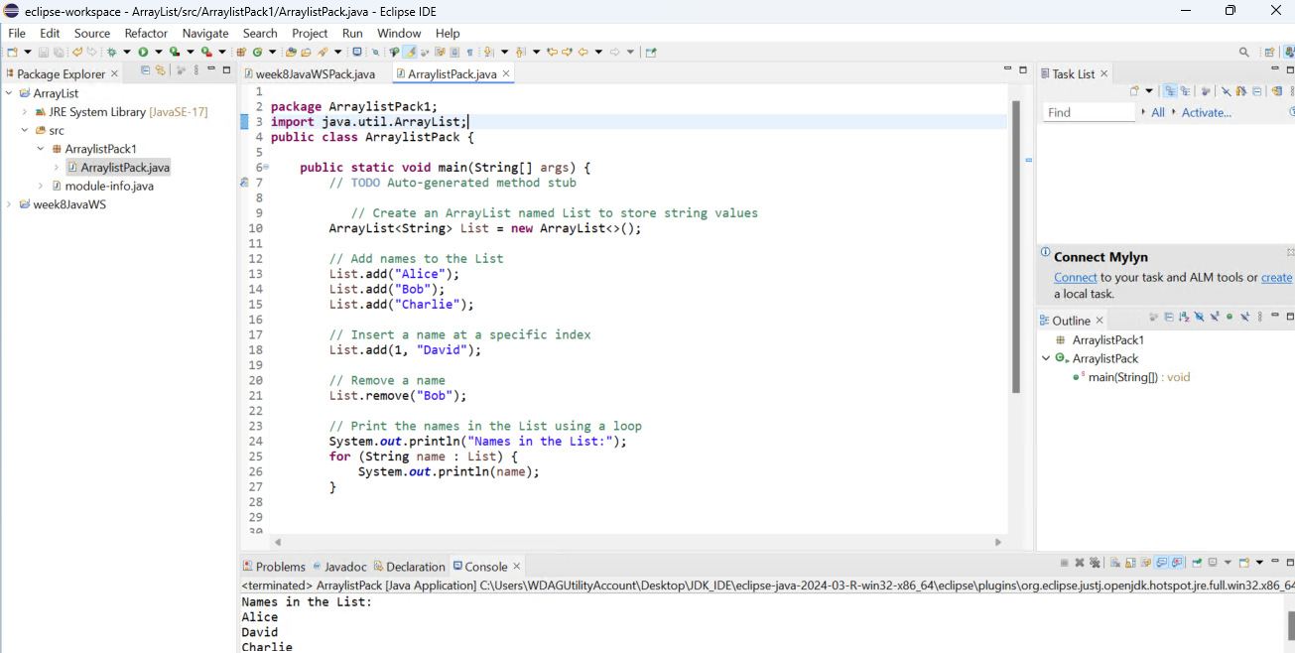

3. Ans:

In an object-oriented payroll system, If I think myself as an employee can be represented as an object with various attributes and behaviors. Some potential attributes and behaviors that an employee object could possess:

Attributes (Member Variables):

1. name (String): The name of the employee.
2. employeeId (String or int): A unique identifier for the employee.
3. dateOfBirth (Date or LocalDate): The date of birth of the employee.
4. address (String or an Address object): The address of the employee.
5. phoneNumber (String): The phone number of the employee.
6. email (String): The email address of the employee.
7. department (String or a Department object): The department the employee belongs to.
8. designation (String): The job title or designation of the employee.
9. dateOfJoining (Date or LocalDate): The date when the employee joined the company.
10. salary (double or Big Decimal): The base salary of the employee.
11. paymentMethod (String or an enum): The payment method (e.g., bank transfer, check, cash) for the employee's salary.
12. bankDetails (BankDetails object): The bank account details for salary transfer.
13. leaveBalance (int): The number of remaining leave days for the employee.
14. employeeType (String or an enum): The type of employee (e.g., full-time, part-time, contract).
15. taxRate (double): The tax rate applicable to the employee's income.

Behaviors (Methods):

1. calculateSalary(): Calculates the salary for the employee based on their base salary, allowances, deductions, and other factors.
2. applyLeave(int daysToApply): Updates the employee's leave balance by deducting the requested number of days.
3. updatePersonalInfo(...): Updates the personal information (e.g., address, phone number, email) of the employee.
4. changeDepartment(Department newDepartment): Changes the department of the employee.
5. promoteEmployee(String newDesignation, double newSalary): Promotes the employee to a new designation with a new salary.
6. terminateEmployee(Date terminationDate): Terminates the employee's employment and updates their status accordingly.
7. generatePayslip(): Generates a payslip for the employee with details like salary, deductions, and net pay.
8. calculateTaxDeduction(): Calculates the tax deduction based on the employee's salary and applicable tax rates.
9. updateBankDetails(BankDetails newBankDetails): Updates the employee's bank account details for salary transfer.
10. requestLeave(int daysToRequest): Requests a specific number of leave days for the employee.

4. Ans:

Let's think about a laptop computer that is in front of me as an object and identify its potential attributes and behaviors.

Attributes (Member Variables):

1. brand (String): The brand name of the laptop (e.g., Dell, HP, Lenovo).
2. model (String): The specific model name or number of the laptop.
3. processor (String or Processor object): The processor or CPU model of the laptop.
4. ram (int): The amount of RAM (Random Access Memory) installed in the laptop, usually measured in gigabytes (GB).
5. storage (int or Storage object): The storage capacity of the laptop's hard drive or solid-state drive (SSD), usually measured in gigabytes (GB) or terabytes (TB).
6. screenSize (double or float): The diagonal size of the laptop's display screen, typically measured in inches.
7. resolution (String or Resolution object): The resolution of the laptop's display screen (e.g., 1920 x 1080, 2560 x 1600).
8. operatingSystem (String or OperatingSystem object): The operating system installed on the laptop (e.g., Windows, macOS, Linux).
9. battery (Battery object): The battery capacity and remaining charge level of the laptop.
10. weight (double or float): The weight of the laptop, usually measured in kilograms (kg) or pounds (lb).
11. ports (List or Array of Port objects): The available ports on the laptop (e.g., USB, HDMI, Thunderbolt).
12. webcam (boolean or Webcam object): Indicates whether the laptop has an integrated webcam or not.
13. touchscreen (boolean): Indicates whether the laptop has a touchscreen display or not.
14. price (double or float): The price or cost of the laptop.

Behaviors (Methods):

1. powerOn(): Turns on the laptop and boots up the operating system.
2. powerOff(): Shuts down the laptop safely.
3. sleep() or hibernate(): Puts the laptop into a low-power state (sleep or hibernate mode).
4. installSoftware(Software software): Installs a specific software application on the laptop.
5. uninstallSoftware(Software software): Uninstalls a software application from the laptop.
6. connectToWifi(String ssid, String password): Connects the laptop to a Wi-Fi network using the provided SSID and password.
7. disconnectFromWifi(): Disconnects the laptop from the currently connected Wi-Fi network.
8. openApplication(String appName): Opens or launches a specific application installed on the laptop.
9. closeApplication(String appName): Closes or terminates a running application on the laptop.
10. adjustBrightness(int level): Adjusts the brightness level of the laptop's display screen.
11. adjustVolume(int level): Adjusts the volume level of the laptop's speakers or audio output.
12. updateSoftware(): Checks for and installs available software updates or operating system updates.
13. checkBatteryLevel(): Retrieves and displays the current battery level of the laptop.
14. chargeBattery(): Charges the laptop's battery when connected to a power source.

Submitted By: Wasik Gaus.

Id - K240381